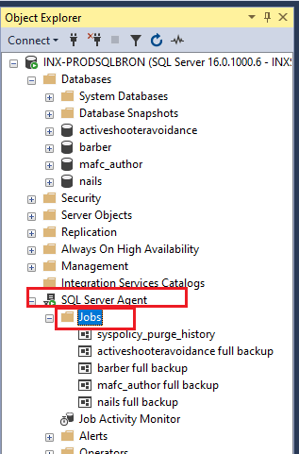
J

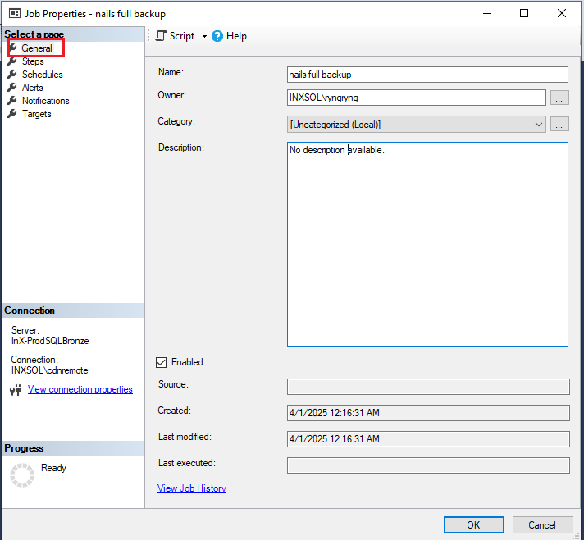

j

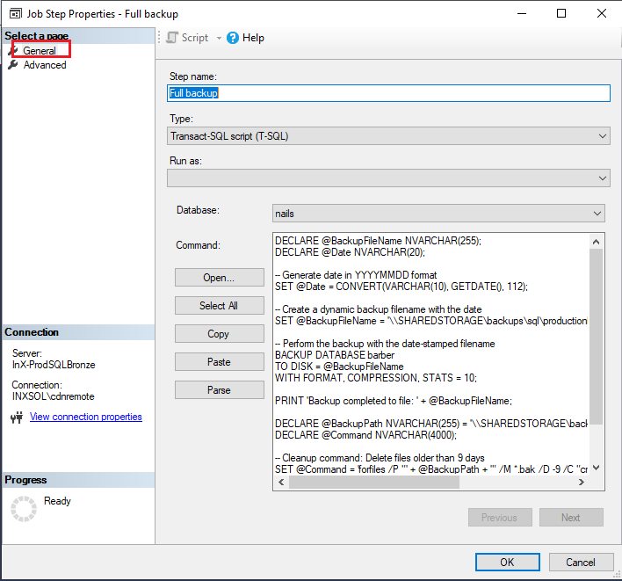
l

DECLARE @BackupFileName NVARCHAR(255);
DECLARE @Date NVARCHAR(20);

-- Generate date in YYYYMMDD format
SET @Date = CONVERT(VARCHAR(10), GETDATE(), 112);

-- Create a dynamic backup filename with the date
SET @BackupFileName = '\\SHAREDSTORAGE\backups\sql\productionbronze\nails\nails_' + @Date + '_FullBackup.bak';

-- Perform the backup with the date-stamped filename
BACKUP DATABASE barber
TO DISK = @BackupFileName
WITH FORMAT, COMPRESSION, STATS = 10;

PRINT 'Backup completed to file: ' + @BackupFileName;

DECLARE @BackupPath NVARCHAR(255) = '\\SHAREDSTORAGE\backups\sql\productionbronze\nails\';
DECLARE @Command NVARCHAR(4000);

-- Cleanup command: Delete files older than 9 days
SET @Command = 'forfiles /P "' + @BackupPath + '" /M *.bak /D -9 /C "cmd /c del @path"';

-- Execute the cleanup command
EXEC xp_cmdshell @Command;

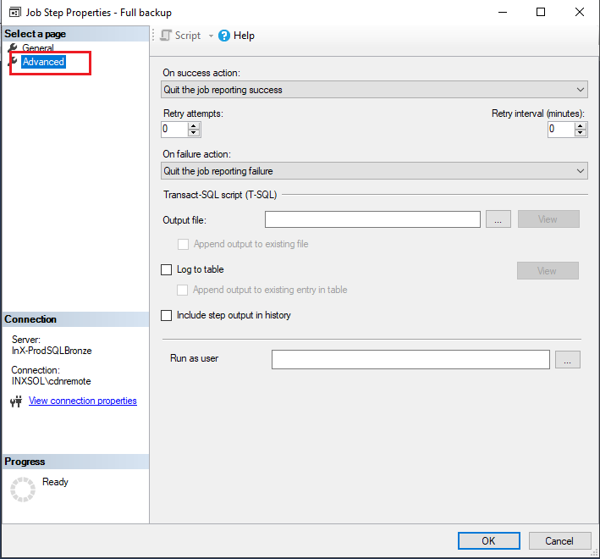

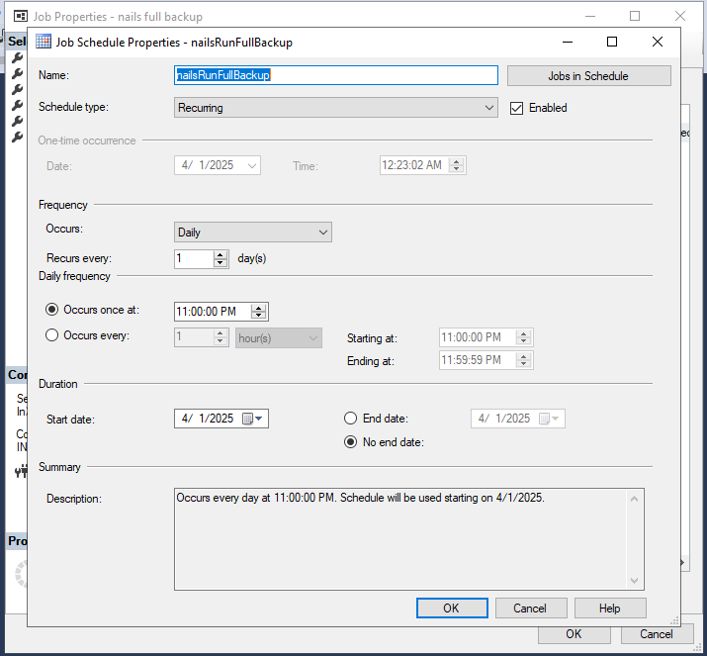
J

----------------------------------------------------------------------------------------------

Script to backup of transaction log and delete old one:

-- Variables for Transaction Log Backup
DECLARE @TransactionLogFileName NVARCHAR(255);
DECLARE @Date NVARCHAR(20);
DECLARE @BackupPath NVARCHAR(255) = '\\SHAREDSTORAGE\backups\sql\productionserver\hazready\';
DECLARE @Command NVARCHAR(4000);

-- Generate date and time in YYYYMMDD_HHMMSS format
SET @Date = FORMAT(GETDATE(), 'yyyyMMdd_HHmmss');

-- Create a dynamic backup filename with the date and time
SET @TransactionLogFileName = @BackupPath + 'hazreadyproduction_' + @Date + '_LogBackup.trn';

-- Perform the transaction log backup
BACKUP LOG HazReadyProduction
TO DISK = @TransactionLogFileName
WITH COMPRESSION, STATS = 10;

PRINT 'Transaction Log Backup completed to file: ' + @TransactionLogFileName;

-- Cleanup command: Delete transaction log files older than 8 days
SET @Command = 'forfiles /P "' + @BackupPath + '" /M *.trn /D -8 /C "cmd /c del @path"';

-- Execute the cleanup command
EXEC xp_cmdshell @Command;

PRINT 'Cleanup of transaction log files older than 8 days completed.';

